Kalen McNab r3 report
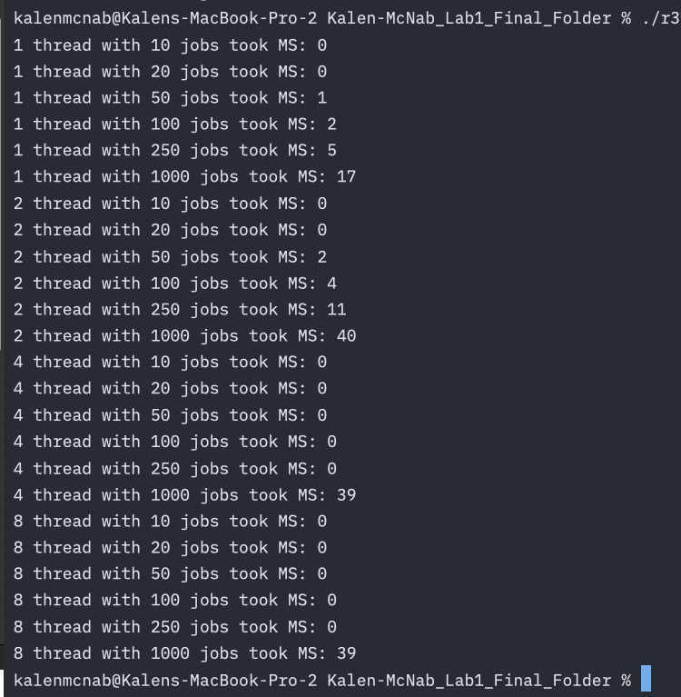
Here are the results from r3. Here what we notice most jobs handle lower jobs without an issue which is to be expected 0 milliseconds but then we start noticing especially in the 1 and 2 threads when they hit 50 jobs and more, they start increasing. This it to be expected as the multitude of jobs increase so does the time it takes to complete them, but we also notice for 2 threads the time almost doubles in some spots why: overhead. With us needing to handle locks and check variables it starts creating overhead because we add time managing the memory and threads safely to avoid issues but where we see the threads shine is with 4 and 8. All jobs up to 1000 jobs is 0 milliseconds, why is this even though we introduce a ton of overhead with needing to handle multiple threads. We have enough threads to space out the jobs that it stays under 0 but when the jobs hit 1000 we notice 4 and 8 hit 39, 2 threads at 40, and 1 thread at 17. Now why is that? Well it varies on many things but it is overhead because with needing to handle threads and our memory safely causes more time to be used where as if we use one thread we don’t worry about this because we don’t need to protect everything like we would such as race conditions and deadlock we just let it run. Yet this differs for every case, in my case I am not doing complex functions that may require a thread to spend more time executing, it also depends on the number of jobs and their tasks, but also how many locks, barriers, and conditional variables there may be. In the end it comes down to our best knowledge when working with these items as goes the old adage: too much of a good thing is not always good, and we see that with threads. While they are amazing in what they do we don’t need 8 threads to handle 10 or 20 jobs whereas 1 thread can handle it fine as the more threads we introduce the more overhead we create. Too many chefs in the kitchen is not always a good thing they may get into each other’s way and slow down simple tasks.

